Choose your specialisation:
Note: to go back to the last page you visited, please use the button “Abbrechen” (to abort) or “Zurück zur Übersicht” (back to overview). (Marked in green)

1. Click on „Mein Studienplaner“ (My study planner):
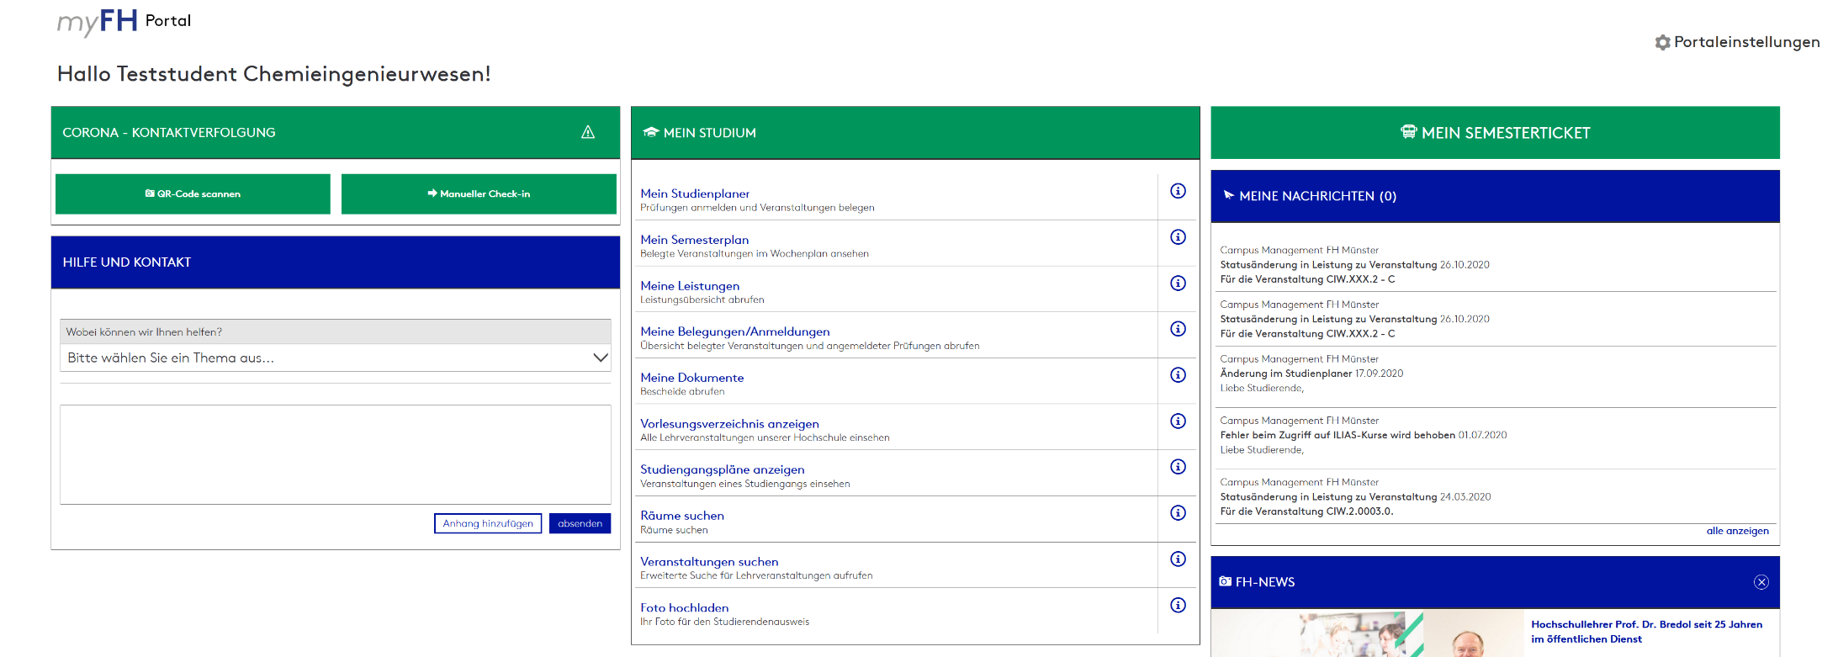

2. Click on „Prüfungsordnung anzeigen“ (examination regulations)
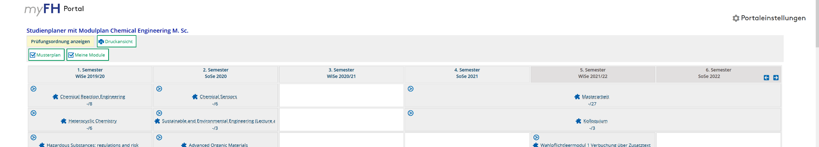

3. Register for one specialisation, by clicking on „Anmelden“ (Sign in):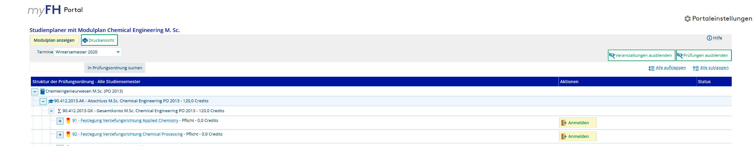

4. Click on “Anmelden” (sign in) to Confirm choice:
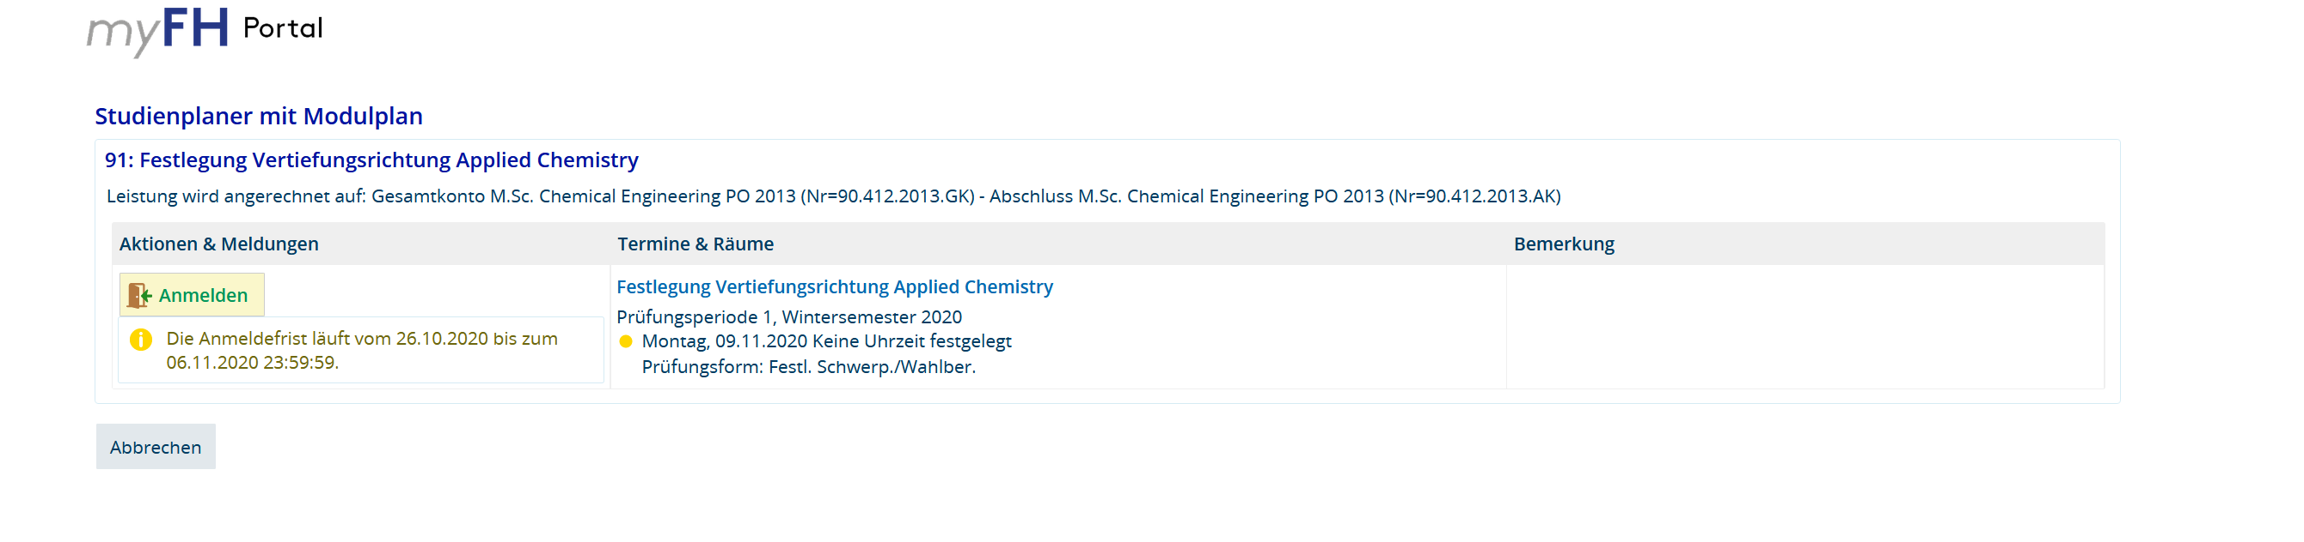
5. Confirmation of your regristation will appear:
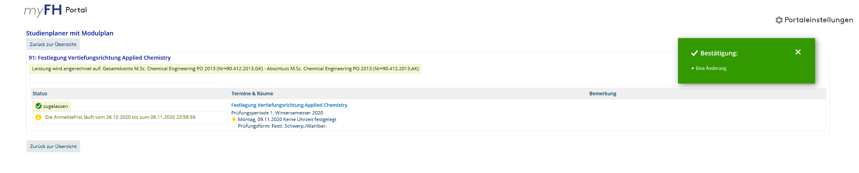

If you want to change your choice:
6. First you have to sign out of your old choice, by clicking on “Abmelden” (sign out):

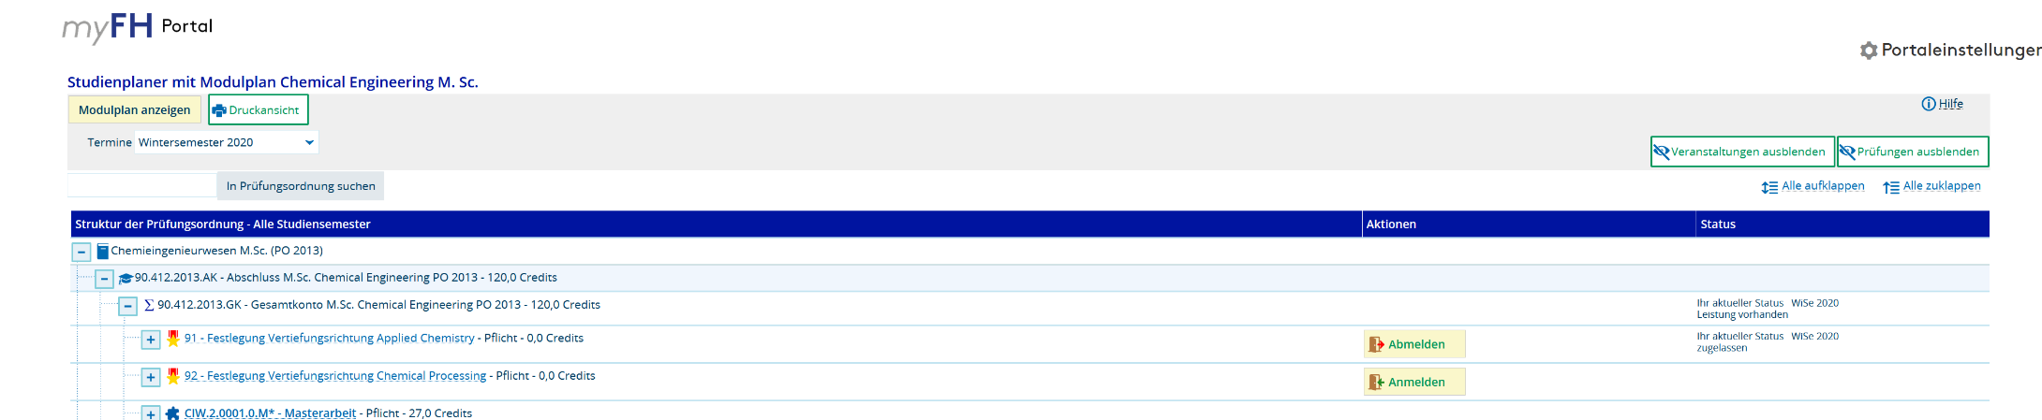

7. Click on “Anmelden” (sign in) to Confirm choice: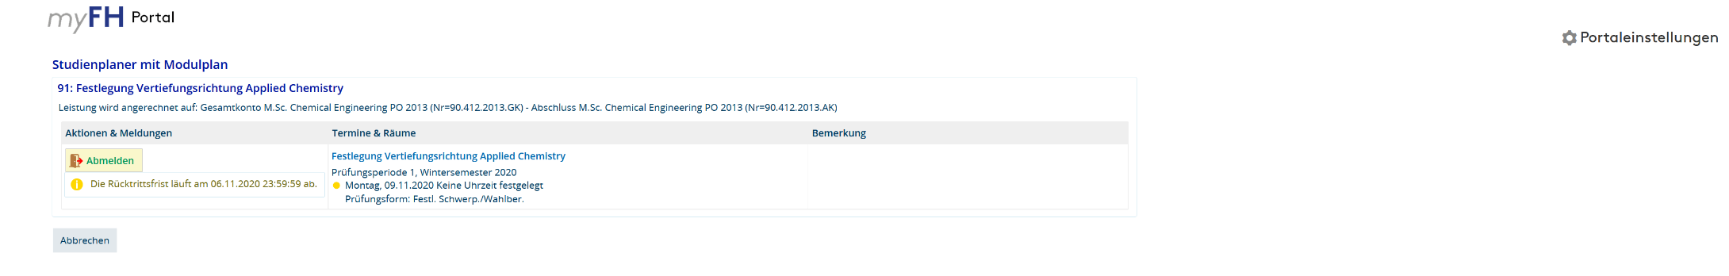

8. Confirmation of your cancellation will appear:

9. Then register for the other specialisation by repeating step 3 – 5.

